ANNUAL REPORT 2021

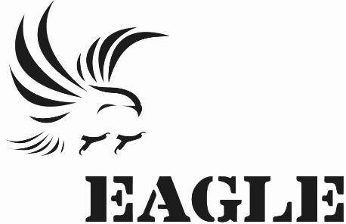

**SYNOPSIS**

EAGLE Uganda has been in existence since October 2018 with field activities centralized more in the capital City “Kampala” with afew intercity missions. Focus is on the fight against corruption and illegal wildlife trade mainly trafficking in ivory, big cat skins and pangolin scales

The project still struggles with growing the team in respect to the structural departments in place, but irrespective of the challenges the EAGLE Uganda team pushed to ensure that project goals are achieved and successfully obtained tangible achievements in its collaboration with Uganda Revenue Authority Customs and Intelligence Departments.

Regardless of the Covic19 measures and the government SOPs, the team was quick to adapt and strategize on how best they could conduct project activities while protecting and minimizing the risk of exposure, several tests on the team were done to emphasize on this.

Direct contact with traffickers in big cat skins (Lions and Leopards), pangolin scales and ivory tusks was more rampant. The project recorded 4 traffickers arrested in the months of March and June with 3 failed operations.

4 traffickers were arrested with 1 sentenced (25% representation) and 3 released on bail (75%

representation). The project was also chanced to work with one investigators from LAGA

(branch network) to provide technical assistance during investigations and operations.

**EAGLE Uganda work has been supported by RUFFORD and AVAAZ**

**ABSTRACT**

**Investigations**

* 511 Field Investigation, missions were carried out in the districts of Kampala, Arua, Pakwach, Kasese, Mukono, Entebbe, Kibale, Mubende and Bundibujjo.

**Operations**

* Operations were carried out in 2 regions arresting 4 traffickers with 1 court case still running.
* Operations on ivory trafficking accounted for 100% of the arrested traffickers.

**Legal**

* 1 court judgment was passed during the year.
* 2 traffickers were found guilty and handed either of the following: Prison sentences, Court Bail, fines..
* The year has majorly been ear-marked with various meeting in trying to foster collaborations with Uganda Wildlife Authority (UWA), Financial Investigations Authority, (FIA), Uganda Revenue Authority (URA), Uganda Prisons, Interpol Uganda, Uganda Police, Directorate of Public Prosecutions (DPP), Ministry of Tourism and Wildlife.
* New cases on bail application at the Anti Corrupt Division and on plea bargain were attended.
* Successful collaboration with CCU on following-up on major Vietnamese case.

**Media**

* Department has not been functional.

**Management**

* Online reports were readily made available
* Enhanced Internal management and department collaborations with emphasis on the project spirit, team work ,output, communication adherence to procedures irrespective of the challenges faced.

**External Relations**

* The department has not been fully functional but the legal department has been at the fore front in trying to pursue the cause with several meeting held with Ministry of Tourism and Wildlife PS, and other government agencies to discuss issues on collaboration.

**Fostering Activism**

**Focus**

* Strategic focus for the year under review was to crack down and arrest all those involved in the illegal trade
* Focus was centralized on growing the team, encourage team work, trust-building and pushing for operations, adherence to project policies, and respecting both project and government measures in curbing and preventing the spread of Covid-19.

**TABLE OF CONTENTS**

**-** Synopsis............……......................................................................................................1

**-** Overview ......................................……..........................................................................2

**-** Table of Contents ...............……....................................................................................4

**-** Narrative Report ....................................…….................................................................5

1 Investigation ................................................……..........................................................5

2 Operations ............................................……..................................................................6

3 Legal ...................................................................................…….....................................6

4 Media ...................................................................……...................................................7

5 Management.........................................................................................................….....8

6 External Relations and Policy...........................................................................…..........9

7 Fostering Activism ......................................................................……………...................9

**Annexes**

Annex I – The Semester in Pictures …………………………...………………………..........................10

**Charts & Tables**

1 Figure 1: Number of investigation missions per month .................................................5

2 Figure 2 Operations Table ……………………………………………………………….............................6

3 Figure 3: Legal Department Performance Analysis..........................................................7

Contact person: lydia@eagle-uganda.org

**NARRATIVE REPORT**

This report covers EAGLE Uganda’s activities from January to December 2021 reflecting the performance of each department from Investigations, Operations, Legal, media and management.

## INVESTIGATIONS

The investigations Department conducted 511 field investigations/missions in 9 regions of the country. The department was directly under the coordination and supervision of CCU investigations and security officers to boost, advice and help with complex investigations.

External support from LAGA investigation unit was a plus leading to the very first operation since inauguration.

Weekly department meetings were held to evaluate field performance, plan and strategize for missions, discuss and adopt new techniques on investigations and on how best to revive the team spirit with the aim of delivering results.

The team was able to adopt new strategies for investigations following the long periods of lockdown due to the pandemic.

***Fig 1: Number of missions/investigations per month.***

## OPERATIONS

In March, 2 traffickers at the helm of an ivory network were arrested in Bugolobi a suburb in Kampala in custody of 14Kgs of ivory. A suspicious photo of a human skull was discovered in one of the traffickers phones and this was pending investigations. Both traffickers were arrested with once sentenced to Kitalya Maximum prison and the other bailed out after spending afew weeks in prison.

In June, 2 traffickers were arrested with 25Kgs of ivory in Kajjansi along Entebbe Road, both traffickers were arrested and remanded at Kitalya Maximum prison but later granted bail on grounds of the government de-populating prisons during the pandemic. One of the traffickers had been followed up by the investigator for more than a year.

The team had 3 failed operations resulting from poor trust building and failure of the team to coordinate activities in regard to one of the operations, this eventually led to the suspension of all the projects activities effective 29th November 2021.

***Operations Table***

|  |  |  |
| --- | --- | --- |
| **Number of operations** | **Number of traffickers** | **Contraband** |
| **2** | **4** | **39 kgs of ivory** |

***Fig 2: Operation Table***

1. **LEGAL**

For the year under preview, 10 new cases were in court, 2 of which were as a result of the EAGLE Uganda operations. These were scheduled and followed up, tried in the Wildlife Court and the Anti Corruption Division , jail visits were directly connected to the project’s arrests.

Several missions were conducted within and outside the city center to follow-up on cases, jail visits and several other meetings with relevant government agencies in trying to foster collaborations with Uganda Revenue Authority(URA), Uganda Wild Life Authority (UWA), Finance Investigations Authority (FIA), Uganda Police, Directorate of Public Prosecutions (DPP), Civil Aviation Authority (CAA) .

The Wildlife Court of first instance found the accused Aimable guilty and sentenced him to 9 months, while his partner Clovis was also found guilty but granted bail of 1,000,000/= ($350) to which failure to pay would lead to his sentence. The 2 were arrested in March 2021.

The Wildlife Court of first instance found the accused Jeff and Wilbur guilty and were remanded pending hearing. Both applied for bail and were released on grounds of the government decongesting prisons due to the Covid pandemic. They were arrested in June 2021.

***Fig.3 Legal Department Performance Analysis***

1. **MEDIA**

Several interviews were held but the right candidates not identified. Department was inactive throughout the year.

2 media pieces were written for the Network reports.

2 meetings were held with the respective persons at UBC (Uganda Broadcasting Channel) TV and the New Vision (Bukedde TV) to foster collaborations.

1. **MANAGEMENT**

The year under review was ear marked with effective submission and uploading online financial and activity reports that result from integrating departmental team work-Investigations, Operations, Media, Legal and Management.

To enhance team building, several team building activities were carried out throughout the year including family meals, spending labor day at Uganda Wildlife Education Center, and internal discussions.

Ongoing French class sessions were conducted to enhance on communication with other network branches, this was done in groups with the first group comprising of 3 team member.

The Assistant Coordinator attended a webinar report on corruption presented by the IGG (Inspectorate of Government).

The Assistant Coordinator attended a training on Fraud Detection and measures to curb the vice, this was presented by the Institute of Certified Public Accountant of Uganda.

Covid-19 was a major hindrance to the activities following the government suspending all forms of movements, the team was however well equipped to counteract the pandemic and adherence to both government and office measures in place ranging from the washing of hands with soap, wearing of masks, have the temperature taken before accessing the premises, sanitizing, keeping the social distance and keeping the office aerated at all times.

All team members were directed to mandatory tests at all times if any member of the team tested positive, those exposed were required to return home and isolate for 2 weeks.

A martial arts trainer was hired to empower the team with defensive skills.

Several team meetings were held to evaluate performance, emphasize on adherence to procedures, forecast and set targets, check on controls in place on covid measures and encourage team members to strategize and set goals and ensure they are achieved.

Continuous recruitment was ongoing for the media, legal and investigations departments with several candidates qualifying to start their test period, unfortunately they all resigned before the end of their test periods.

EAGLE Uganda project activities were suspended in November 2021, following events of the team failing to coordinate a possible operation and breach of the projects ethics. Project remains closed until CCU communicates otherwise.

1. **EXTERNAL RELATONS**

The legal team held several meetings and followed up on the same in relating to agreements/on going collaborations.

1. **FOSTERING ACTIVISM**

During this period the project received a report on sexual abuse and followed it up with the involvement of the investigations and legal department by directly going to the field to investigate and interact with respective persons connected to the case. Still ongoing.

Most planned activities where hindered due to the pandemic.

**Annex I – Operation pictures. January-December 2021**

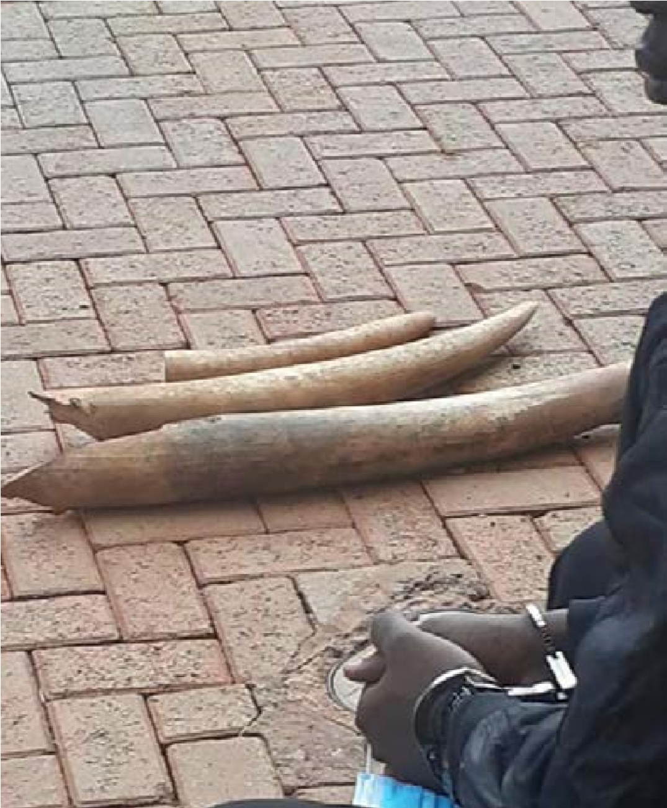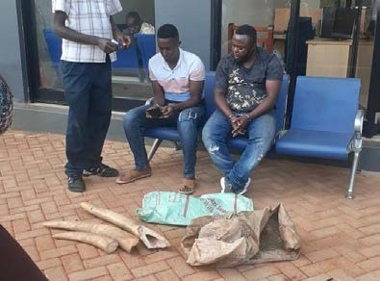

***A pastor and his flock were arrested with 3 tusks of***

***Ivory, taken to URA and sentenced.***

***Took close to 2 years to have these 2 arrested with 4 pieces of ivory. Both were remanded and released on bail while still on trial.***

